Home Learning at Blowers Green

We are really pleased to inform you that we have developed our home learning further and will now be using a new platform called Seesaw. Seesaw will help us work to together to provide your child with meaningful learning experiences at home.
This week, we have spent some time sharing the platform with your child so that they are familiar with See Saw.

What does See Saw do?
Seesaw will enable your child’s class teacher to –
- Set work that is appropriate for your child’s ability
- Give clear instructions and resources
- Mark and respond to your child’s work

It will allow your child to return their work securely.

How do I access See Saw?
See Saw can be accessed on a smart device such as tablet, phone and IPad as well as laptops and desktop computers.

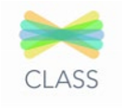
How does my child get started?
- For tablets or phones, download the Seesaw Class App
For laptop or desktop computers, go to app.seesaw.me
- Your child logs in by clicking I’m a Student
We have provided a unique Home Learning Code for your child to log in at home: Enter the text code.
This can be found in their Learning Journal and a copy has been provided with this letter.
Step 1
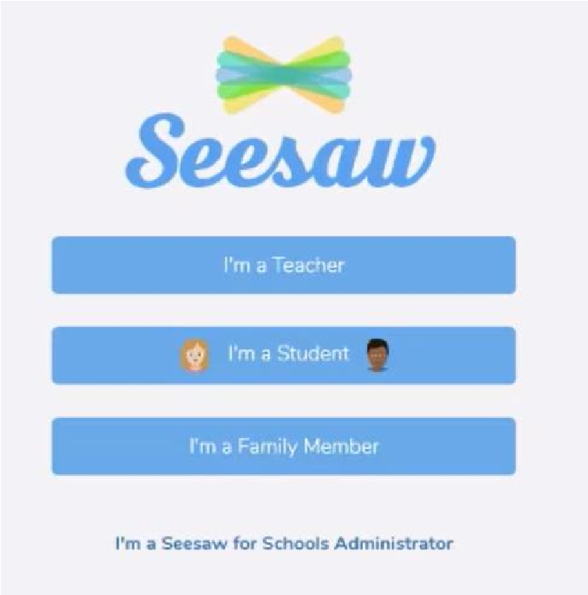
Open the Seesaw App on your child’s tablet: OR go to app.seesaw.me for laptops and computers.

This is the page you will be taken to.

Click on the ‘I’m a student’ button.

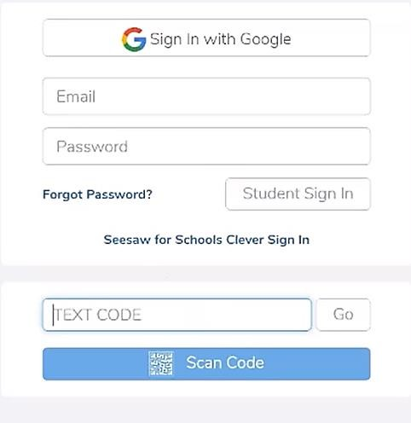
Step 2

Enter your code from school.

Step 3
The 3 main areas of the Seesaw platform are the Journal, Activities and Inbox tabs.
Journal | The Journal is an area which children can use to share learning which has taken place outside of school. | 
Activities | This is an area where teachers post new learning activities. | 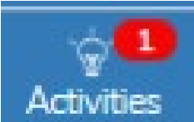
Inbox | Teachers will post whole class and individual messages directly to children via the inbox tab. | 
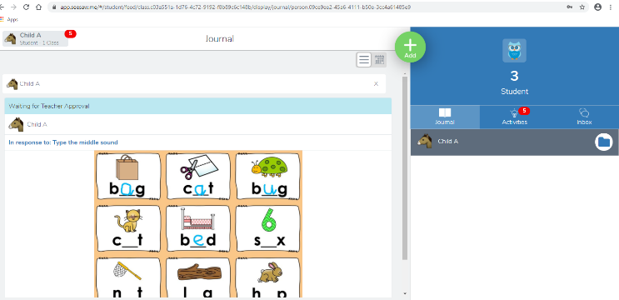
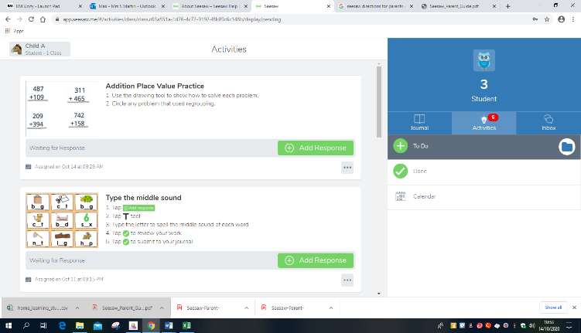

When you log on, any work completed will show in the Journal.
To find any activities set by the teacher, click on the activities tab.
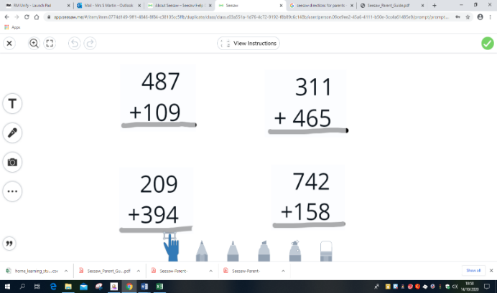
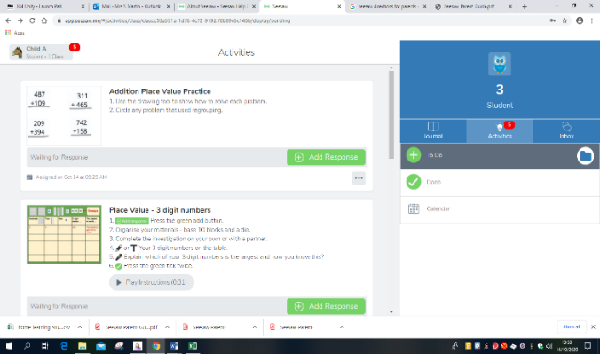
To complete an activity, click add response. Once it has opened, you will be able to type by clicking 
Use a mouse or touch screen to write an answer or write answers on paper, take a photograph and send your answers back.
Tap/Click the green tick in the upper right-hand corner to send to your teacher.

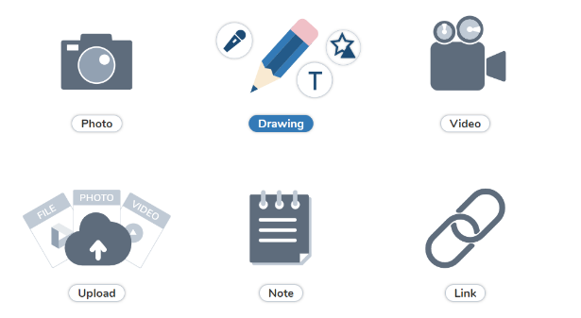

If you have any problems, your child’s class teacher will be able to help.
You can contact your child’s class teacher on the email below.
Yearsix@blowers.dudley.sch.uk

