
Wednesday 8th July 2020 Blowers Green at Home – Nursery
E-mail: nursery@blowers.dudley.sch.uk

Good Morning Nursery!
Below are your ‘Nursery at Home’ activities for today. As always, if you have any questions or would like to share your learning, please e-mail on the address above.


Keep on Moving!
Today, try and copy these fun dance movements. Remember to listen carefully and stop when Jack says freeze.
https://safeyoutube.net/w/6hlN

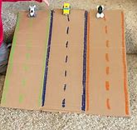
My truck is stuck!
On no, my truck is stuck! Can you help me move it?
Make a ramp for a toy car using some card or a tube. Place one end of your ramp on an on an object such as a box. Hold the car and let it go.
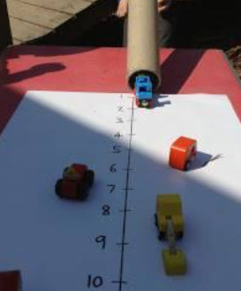
Make a number line at the bottom of your ramp. What number does your car reach? Have a competition with a family member and make marks to record your score.
How can you make your car go further?
How can you make it go faster?

Rhyme Time
Do remember singing this rhyme? Practise singing it today. Can you remember all the words and actions?
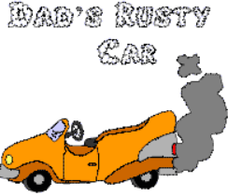
Twinkle, twinkle chocolate bar,
My daddy drives a rusty car.
Start the engine pull the choke,
Off we go in a cloud of smoke.
Twinkle, twinkle chocolate bar,
My daddy drives a rusty car.

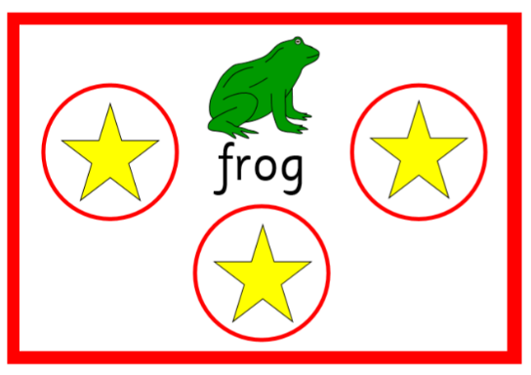
What can you see?

Can you find the pictures which rhyme with frog?




That’s right frog, dog, fog and log.
Can you think of any more rhyming words?

Funky Fingers - I need a hair cut!
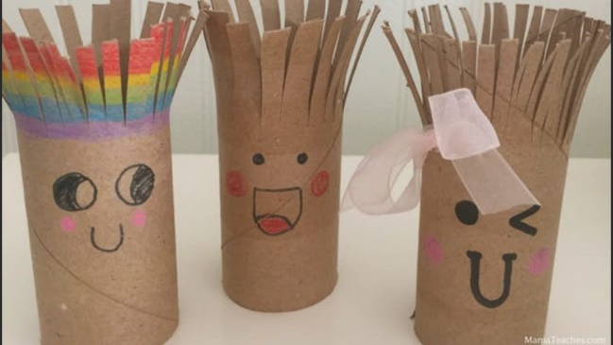
Well, just like these kitchen roll models, I am really looking forward to getting my hair cut.
You will need some child scissors, kitchen roll tubes, some felts or crayons and an adult to help you.
Decorate your tube person however you wish. To make the hair, ask an adult to help you to make snips in the top of the tube. When you have finished, you could even give your tube a hair cut!
Note to Parents
Please supervise your child when using child scissors. Your child may need help to hold the scissors and to make the open, shut action.

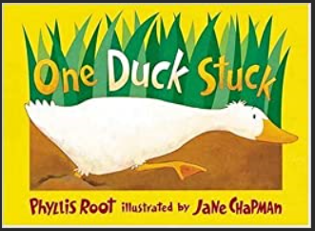
Number Story – One Duck Stuck
Another duck is stuck! Share this number story all about a duck who got stuck in the muck. What numbers can you see? Can you count the animals who tried to help?
https://safeyoutube.net/w/gPlN
There are some animals in this story which may be new to you.

moose cricket skunk possum
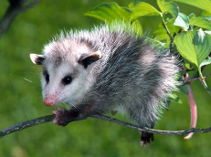
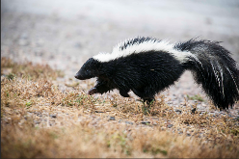
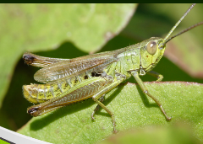
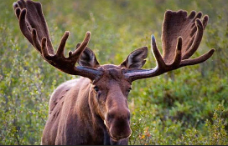

Choose an animal, ask an adult to help you find some facts about it.
Where do they live?
What do they like to eat?

Have a wonderful day
Miss Meads

