 Good Morning Year 5 
Let’s start our day with yoga. Start your day by completing some Cosmic Kids yoga. Find a yoga video that you would like to do today.

Next up is maths.
Today you will be adding decimals together to create a whole.
Choose your chilli challenge below.
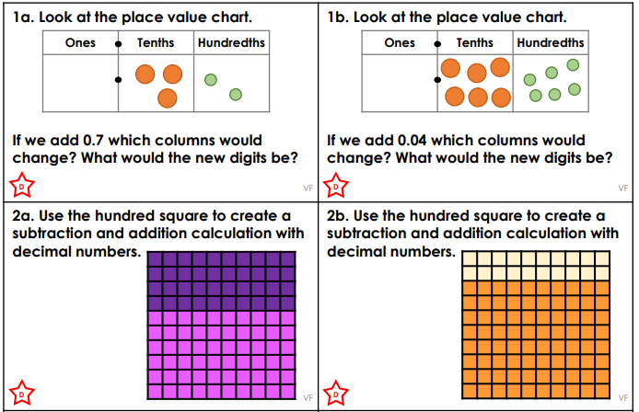
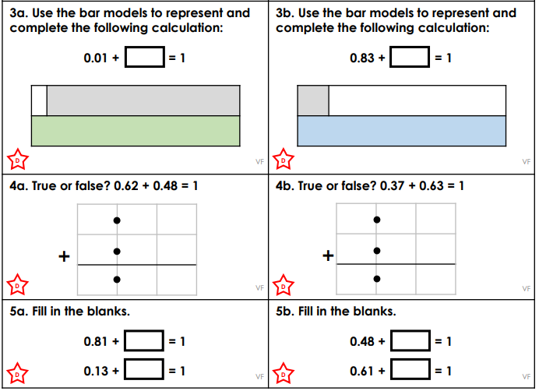
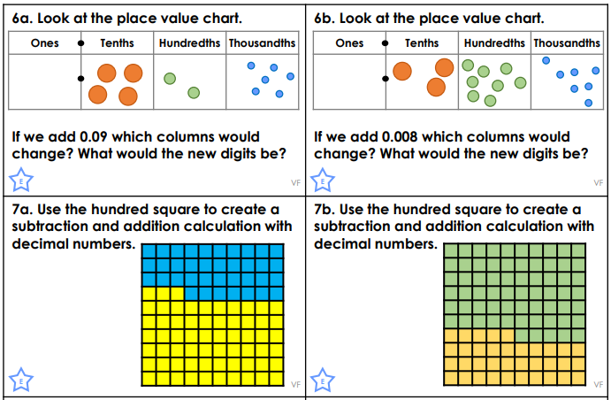
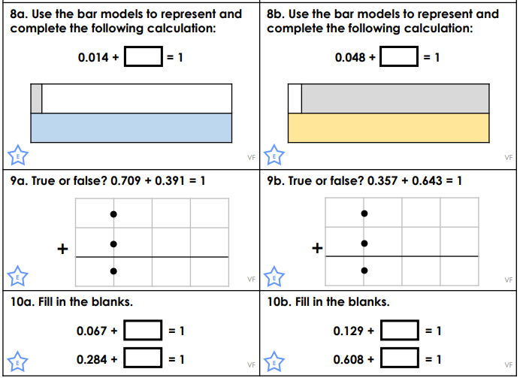
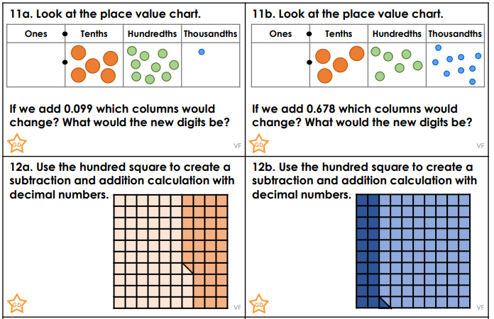
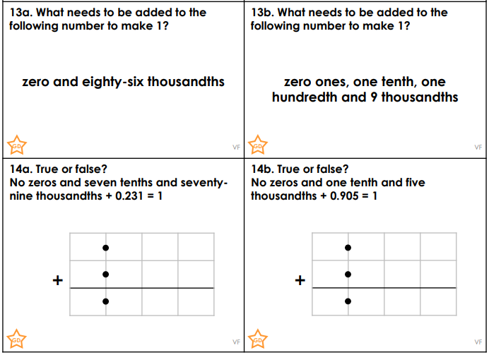

Challenge
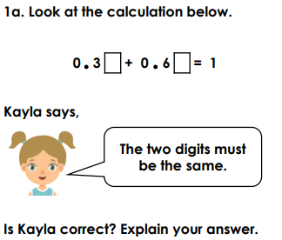 | 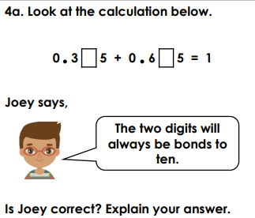 | 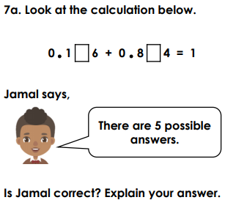
Our next lesson is English.

Today let’s revisit the past perfect tense. Let’s refresh our memories by watching the video below.
https://safeYouTube.net/w/VHvM

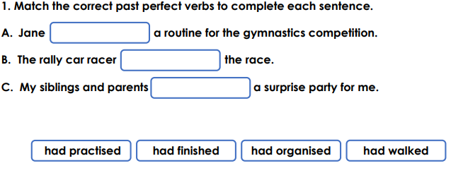
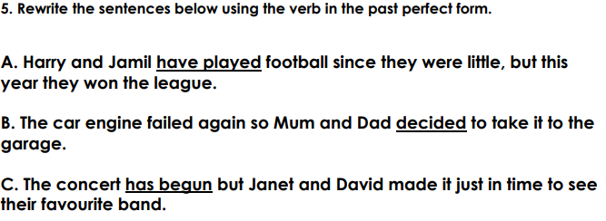
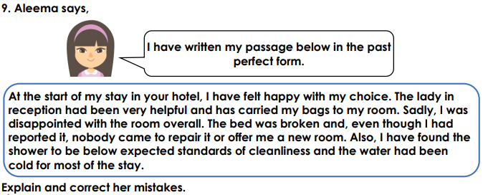

Reading 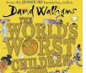
Today we are going to be listening to an extract from the ‘World's Worst Children’ by David Walliams.
https://safeYouTube.net/w/qBQM

The final lesson is science
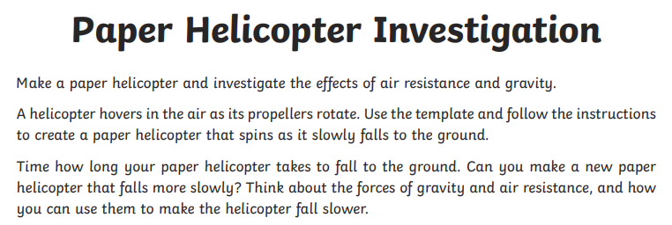
Draw a picture of your new helicopter and explain how you made it slower.

Draw this on a piece of paper.
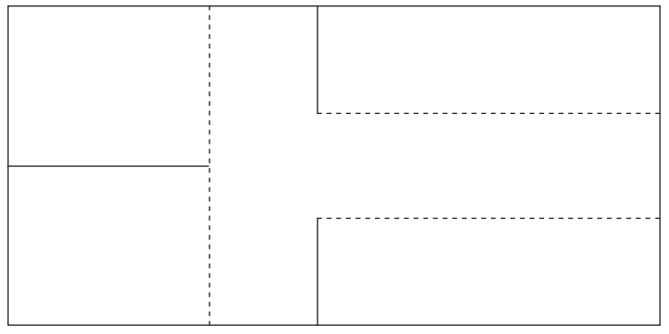

Then follow these instructions.
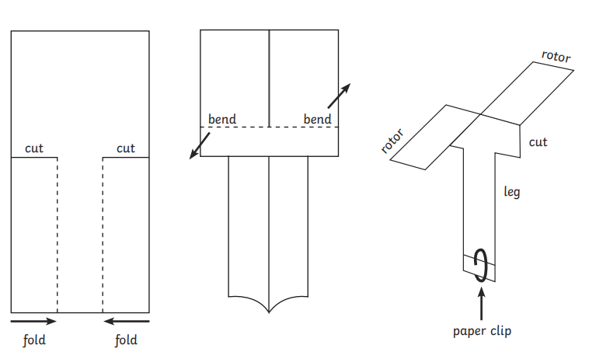

Remember to have time to yourself and to do something you enjoy. Also complete your daily reading.

Maths answers
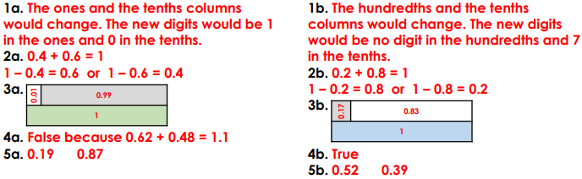
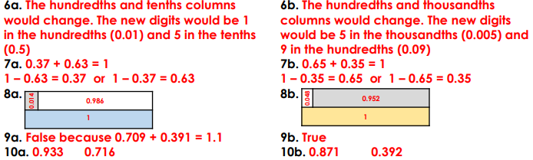
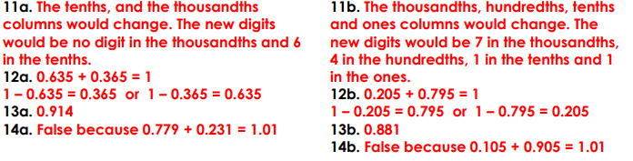

Challenge
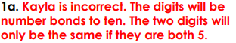 | 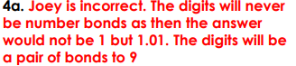 | 

English answers



