
Tuesday 7th July 2020 Blowers Green at Home – Nursery
E-mail: nursery@blowers.dudley.sch.uk

Good Morning Nursery!
Below are your ‘Nursery at Home’ activities for today. As always, if you have any questions or would like to share your learning, please e-mail on the address above.

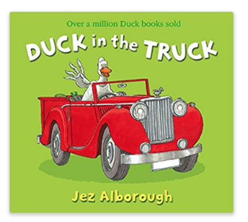
Share a Story - Duck in a Truck
Our story this week is Duck in a Truck. When you read the story today, try to help to tell the story by joining in with the rhyming words.
https://safeyoutube.net/w/XGXM

Can you find the rhyming pairs?
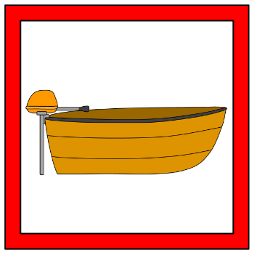

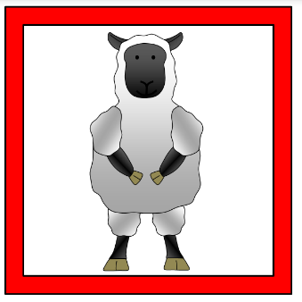
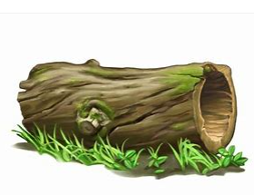


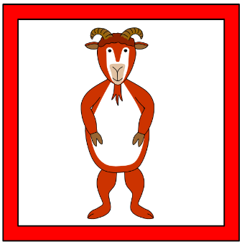



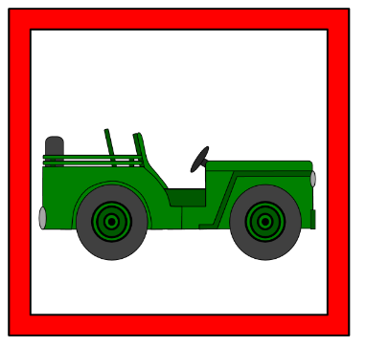

Keep on Moving and listening! Animal Actions
Put on some music to dance to. When an adult calls out an animal action, you must stop dancing and do the action. When they call out ‘free as a bee,’ carry on dancing.

Frog on a log – jump like a frog


Sheep in a jeep – walk on your hands and knees slowly.


Duck is stuck – stand as still as possible, holding your arms out like a duck’s wings.


Free as a bee – start dancing again.
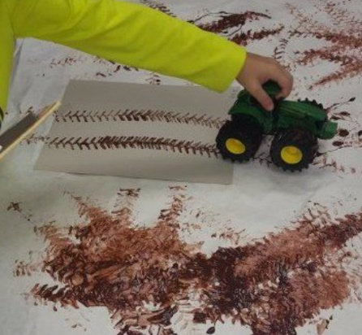
Mucky Mark Making
It’s time to messy with mark making. Grab your favourite cars and make some marks. You could make some real mud by mixing water and soil from the garden. Or, mix some brown paint or cocoa powder with water and flour to make a paste. You can make your mud as runny as you wish.

Phonics
It’s time to add our i sound to our sound book. I drew an igloo, made the colour indigo, found a picture of Iggle Piggle and an invitation.
Click on the link below to hear the phonic sounds correctly.

https://safeyoutube.net/w/rbuM
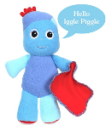
i

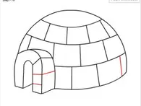
Have a terrific Tuesday everyone!



