 Good Morning Year 5 
Hope you are all well!

Let’s start our day off with a dance. Today you choose if you want to dance with Oti or dance with just dance.

Next up we have maths.
Today you need to practise subtracting decimals within 1.

Choose your chilli challenge below.
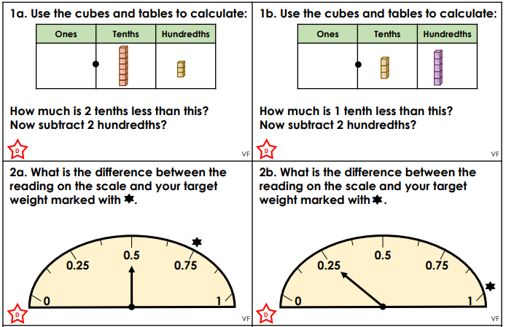
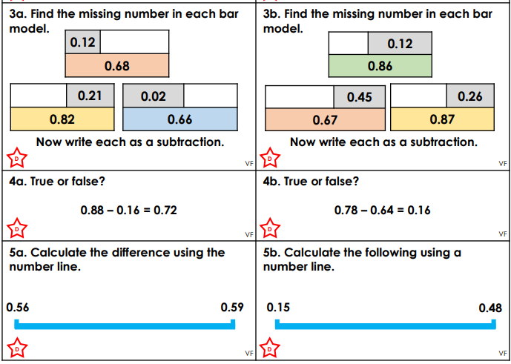
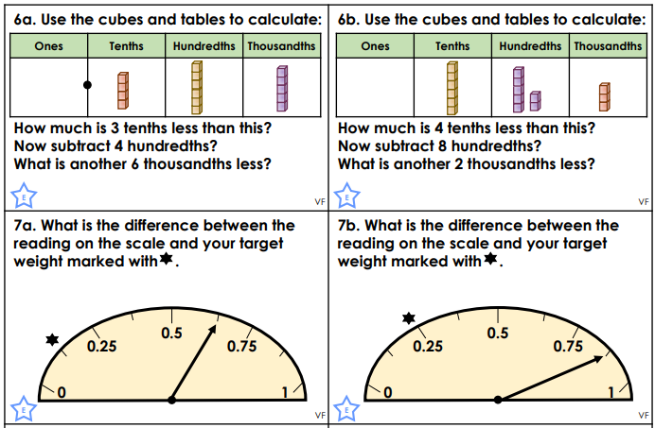
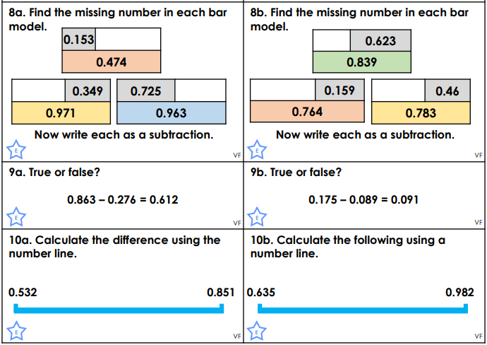
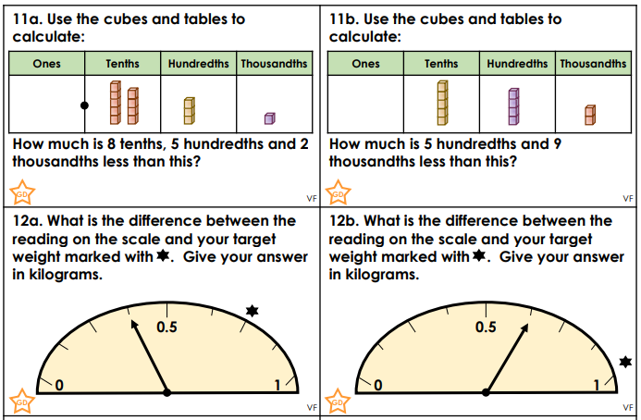
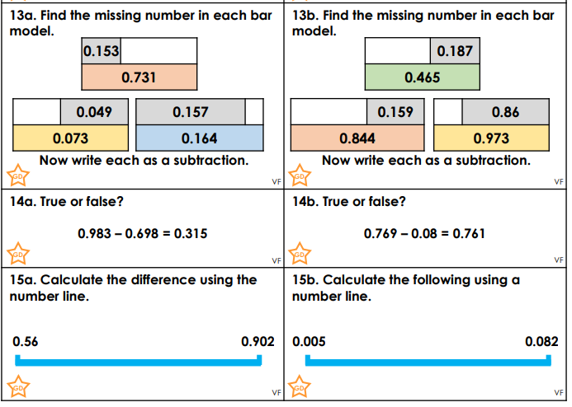
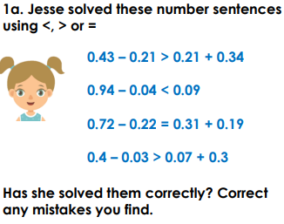 | 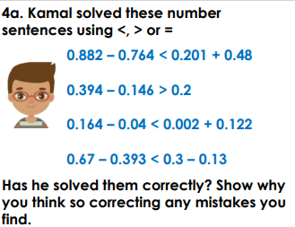 | 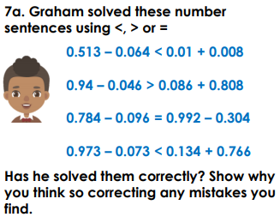

Challenge

Our next lesson is English.

Todays tense is present perfect form. To recap your memory on the present perfect tense please watch this video https://safeYouTube.net/w/0EvM
Now complete the tasks below:
Rewrite the sentences below to include the correct verb using thd perfect present tense.
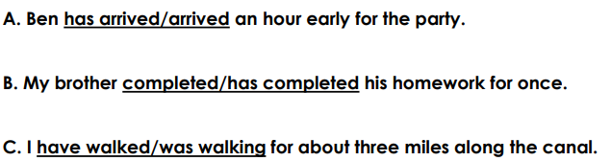
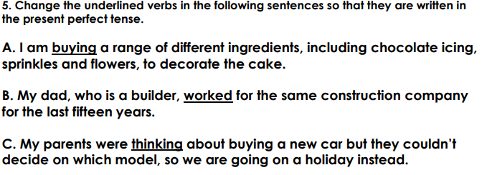
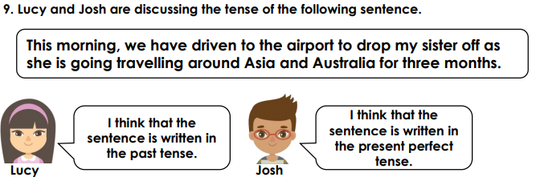

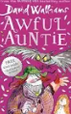
Reading
Today we are going to listen to David Walliams read an extract from his book Awful Auntie.
https://safeYouTube.net/w/DAQM

Our final lesson is Science
Today we are going to be revisiting materials and their properties.
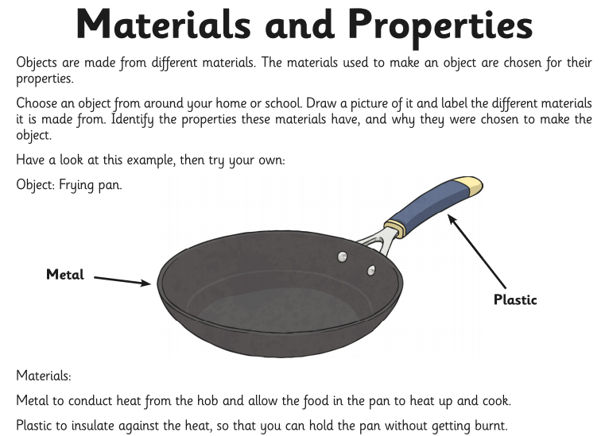
Draw this table in books and complete.
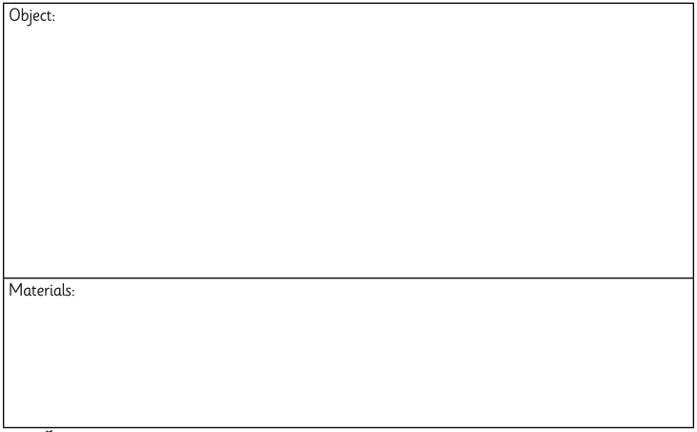

Remember to complete your daily reading and I’d love to hear what book your reading and if you are enjoying it.

Maths answers
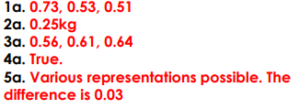  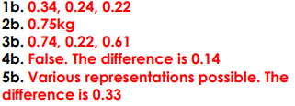 | 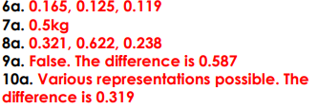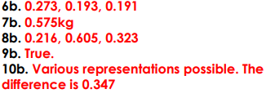 | 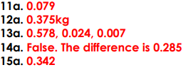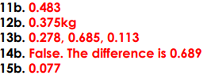
Challenge
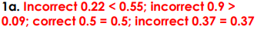 | 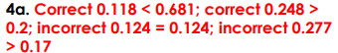 | 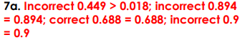

English answers


