Blowers Green at home – Nursery
Monday 8th June 2020
E-mail: nursery@blowers.dudley.sch.uk

Good Morning Everyone!

I hope you have all had a wonderful weekend.
Below are your ‘Nursery at Home’ activities.
Have marvellous Monday
Miss Meads

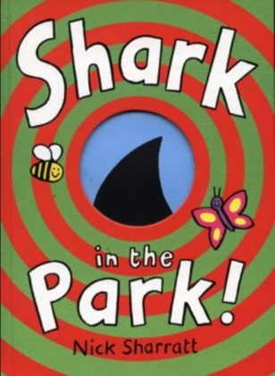
Story Time - Shark in the Park
Have you ever seen a shark in the park? Well this rhyming story is all about a little boy, who is sure he can see a shark in the park.
Can you guess what Timothy really sees? Look at the pictures and listen carefully to the rhyming words.
https://safeyoutube.net/w/4iGJ

Keep on Moving!
I know this song is one of your favourites! So, let’s sing and dance along to ‘Baby Shark.’
https://safeyoutube.net/w/QhGJ

World Oceans Day
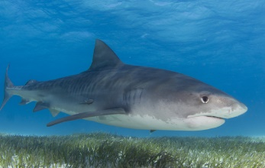
We wouldn’t expect to see a shark in a park, but you might see one in the ocean. Today is World Oceans Day. This is a day to celebrate the ocean and everything that lives in it. I wonder who else might be living in the ocean?

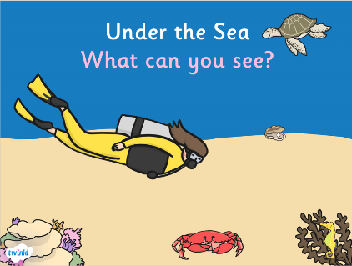
Under the Sea - What can you see?

Play this game with an adult. Look through the binoculars to find out who else might be living under the sea.
You will find the game ‘Under the Sea What Can You See?’ under the Nursery tab on our website.
https://www.dudleyacademiestrust.org.uk/hiddenarea/blowers-green-primary-school-at-home

Ocean Challenge
Draw a picture of your favourite ocean animal. Then, ask an adult to help you find out three interesting facts about it.

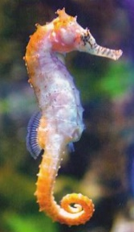
My favourite ocean animal is the sea horse. A sea horse is a fish with a long neck and snout. When they find food, they suck it up their snout like a vacuum cleaner. Sea horses can also change colour.

Reception Challenge
Some of you are due to start school in September. So, each week I am going to set you a ‘Ready for School’ challenge. This week your challenge is to recognise your name. This may take time but if you practise, I know you can all do it!

Everyday activities to help your child to recognise their name.
Make family name cards for the table at dinner time and encourage your child to find their seat. At first, add a picture to help your child then remove it when they become more confident.
Make name labels for your child to attach to their own drawings and paintings

If your child can recognise their name . Practise putting the letters of their name in order.
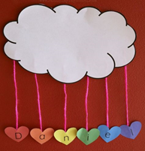
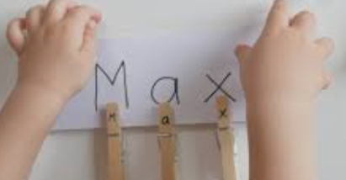
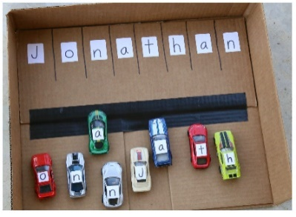
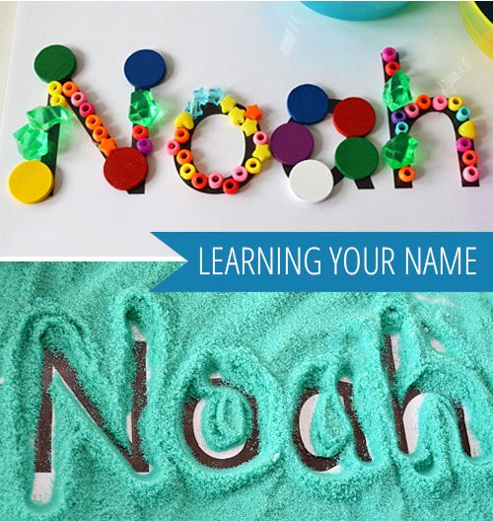

Have a lovely day
Miss Meads

