Friday 26th June 2020 Blowers Green at Home – Nursery
E-mail: nursery@blowers.dudley.sch.uk

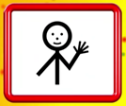
Hello Nursery!
Phew, what a hot and sunny week!
I hope you are using your Makaton signs. There will be some more to learn next week.
Happy Friday everyone and have a safe and happy weekend.

Keep on Moving!
Today, we are going on a yoga adventure. You will need to use your imagination. I wonder who we will meet today.
https://safeyoutube.net/w/28xM

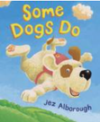
Share a Story
Remember to share a story for at least ten minutes every day.
I hope you enjoyed our story ‘Some Dogs Do.’ When you read it today, I would like you to listen carefully and try and join in with the rhyming words.
https://www.booktrust.org.uk/books-and-reading/have-some-fun/storybooks-and-games/some-dogs-do/

Make a Sid Puppet
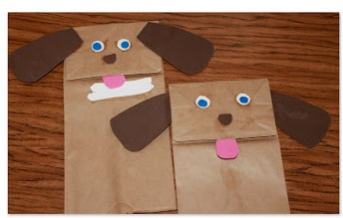
Make a Sid puppet. You can use him to help you join in with the story. All you need is a paper bag. Then, decorate your bag to look like a dog. When we have a windy day, I’m going to add some string to my dog and take him out to fly!

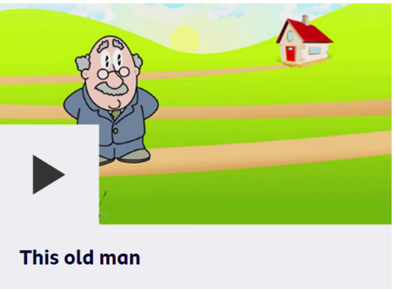
Rhyme Time
Here is a new rhyme for us to learn. Join in and sing along to ‘This Old Man.’

https://www.bbc.co.uk/teach/school-radio/nursery-rhymes-this-old-man/z4w4vk7
Rhyme challenge
Can you think of some rhyming words for six, seven, eight, nine and ten?
I will start you off.
This old man he played six
He played knick knack on my sticks.
With a knick knack, paddy wack give a dog a bone,
This old man came rolling home.

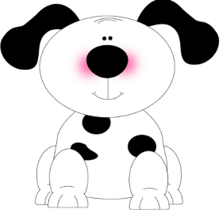

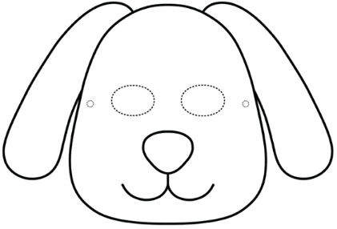
Maths – Spotty Dogs

Ask an adult to help you draw a dog. Your adult will need one too. You will need some objects to use as spots such as buttons, cereal or counters. You could make some spots out of card or paper.
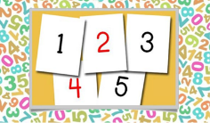
Now choose your challenge.

Challenge 1
Take it in turns to roll a dice or take a number card. Count out the correct number of spots and put them on your dog. Remember to count carefully. Now, take off the spots and roll the dice again.

Challenge 2
Play this game with your family. Who can make the spottiest dog? Set a timer for 5 minutes. Take it in turns to roll a dice or take a number card. Count out the correct number of spots and put them on your dog. Keep taking turns to roll the dice and add more spots to your dog. When the timer stops count how many spots you have on your dog altogether. Who has more spots? Who has fewer spots? How do you know?

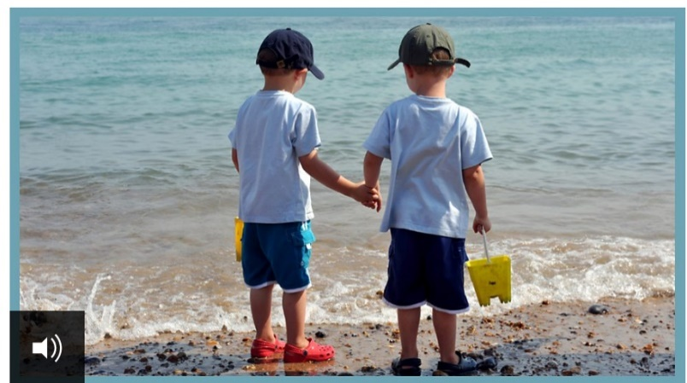
Senses Challenge
Listening Game
Click on the link below. Close your eyes and listen to the sounds. What can you hear? How may sounds did you guess correctly?
https://www.bbc.co.uk/teach/school-radio/eyfs-outside-sounds/zjyvt39

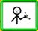
Have a lovely weekend

Miss Meads

