Good Morning Year 5

Let’s start our day with maths.
Today you are going to identify, name and write equivalent fraction by multiplying or dividing.
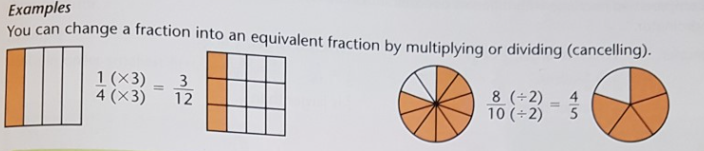
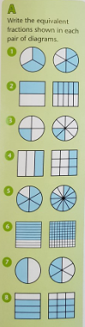 | 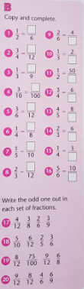 | 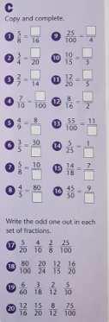

Our next lesson is English.
The newspaper below is about Captain Tom Moore, who raised millions of pounds for the NHS during lockdown. Read the newspaper article and answer the questions below.
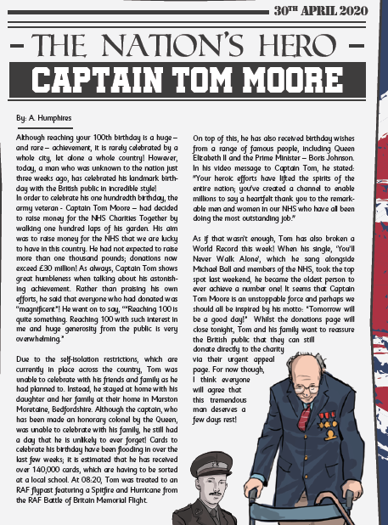
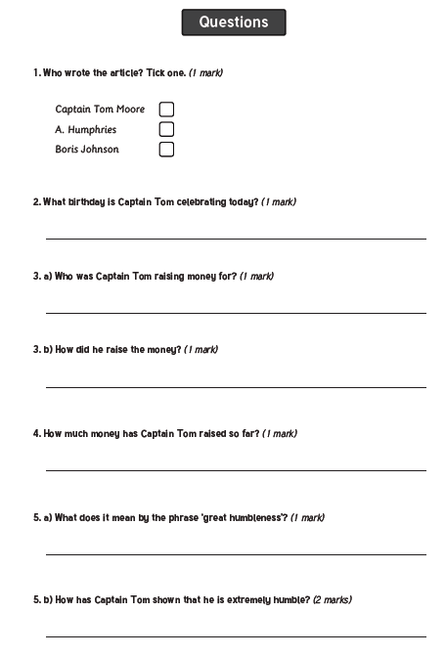
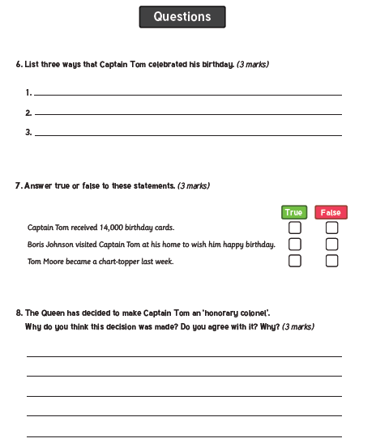

Our final lesson is music.
Listen to the song ‘Short Ride in A Fast Machine’ by John Adams.
https://safeYouTube.net/w/ra7K
Then draw what you see when you listen to the music and/or write a poem/short story about what you imagine while you listen to the music.
Think: • What do you imagine when you hear this music?
• How does it make you feel?

Finally, it is Father's Day on Sunday. To show how much we care for the father figures in our lives I would like you to think of something special to do for them. You could make them a Father's Day card, breakfast in bed, tidy your bedroom, bake a cake or you can ty one of your own ideas. Remember to tell them how much you care for them!
I hope you all have a lovely weekend!
Maths answers
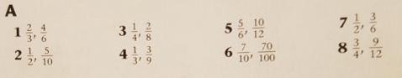
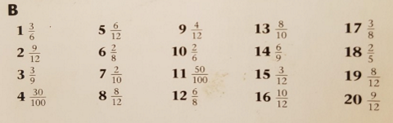
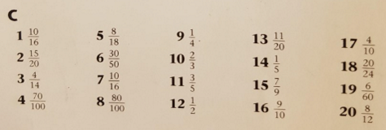

English answers are on the next page.
