Friday 5th June
E-mail: reception@blowers.dudley.sch.uk
Good morning. Thank you all for working so hard this week. Wait till Monday to see all the Dojo points you have scored. You will be amazed.
I hope you enjoy the activities today.
Poster challenge.
You still have time to send in your picture for the poster.

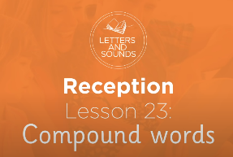
Phonics
If you know all the sounds on your phase 3 mat this is the lesson for you. Today you are learning how to read and write words compound words. https://safeYouTube.net/w/iaqJ
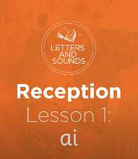
If you are finding it hard to remember all the sounds, don’t worry, try this lesson. Here you will be learning to read and write words with the ‘ai’ sound. https://safeYouTube.net/w/GSpJ

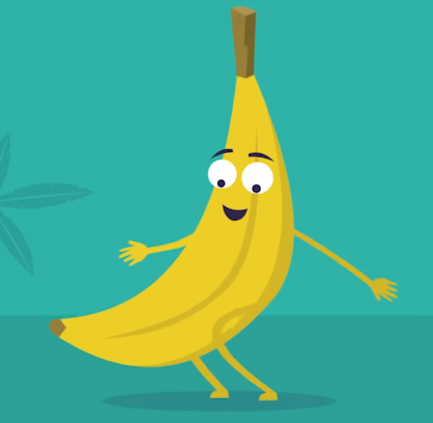
Yoga
Let’s go on a yoga adventure with Betsy, a banana. Can you make a banana shape with your body? Betsy has three wishes. Can you remember what dreams Betsy had? What dreams do you have?
https://safeYouTube.net/w/2RpJ

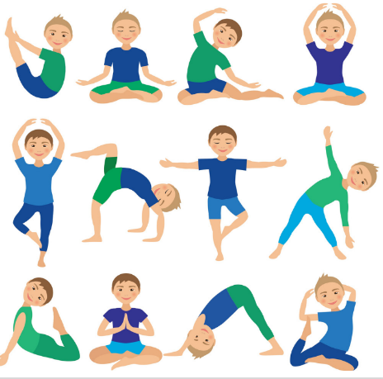
Look at these yoga poses. Can you do any of them? Some are easier than others. Pick a position and see if you can hold the position while you do 3 deep breaths.

Number Challenge
Yesterday we looked at sharing into two groups to find half a number. Below are some tricky questions for you.
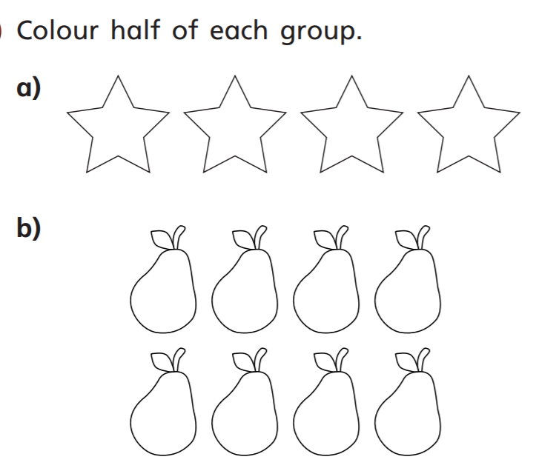

Molly made 6 cupcakes whilst I was at work yesterday. She ate half of them. How many was left when I got back?

Draw 8 bottles of paint on a classroom shelf. Colour half the paint in blue. How many bottles are blue?

Challenge.
Today, with the help of an adult can you use their phone to take some photographs. You will need to find things that are red, orange, yellow, green, blue, purple and pink.
Once you have found the object place it on a plain piece of paper and take picture.
I want you to take your own photographs and then an adult will email them to me. I can’t wait to see your photography skills.
Once I have all your photos I will put them on the home learning page for you to see each other’s skills.

I tried to take a picture of something white. Can you work out what it is?
I think I need more practice.

I look forward to seeing all your work.
Have a lovely weekend with lots of smiles.
Mrs Macdonald

